**University personnel shipping anything internationally (materials, documents, equipment, specimens, etc.) should utilize eShipGlobal.**
The University's preferred on-line shipping service is eShipGlobal. Using eShipGlobal as your source for all shipments, domestic and international, will ensure the best discounted pricing available from FedEx, UPS, Lone Star Overnight, and DHL (international only), as well as 100% HUB credit. From eShipGlobal's site, the user can choose the preferred carrier and service, print shipping labels from their computer, and track packages in transit. Payments will be made utilizing the university ProCard. Using eShipGlobal also provides the user with an added layer of security and minimized liability through its built-in compliance verification checks. Some high technology goods, and other less assuming goods are export controlled depending on their classification and destination. When processing the user’s shipment eShipGlobal will flag any export compliance concerns and/or Dangerous Goods/HAZMAT concerns which will then require approval from UTA’s Office of Regulatory Services (ORS) and/or Environmental Health and Safety (EH&S) respectively. These required approvals help to minimize the user’s liability. In addition, eShipGlobal creates and maintains documentation of shipments helping to comply with federal recordkeeping requirements.
Please visit https://resources.uta.edu/business-affairs/procurement/campus-wide-contracts/preferred-supplier-agreements.php and review the Express Shipping section for more information, and to learn how to set up an account!
eShipGlobal Overview
eShipGlobal training videos
For assistance with international shipments in eShipGlobal, contact regulatoryservices@uta.edu.
INSTRUCTIONS: Processing a shipment in eShipGlobal
Once you have an account, please review the following instructions and guidance to ship internationally.
*When creating your shipment, it is imperative that all information is entered honestly and accurately. eShipGlobal’s system of checks and verifications serves to ensure the user’s and UTA’s compliance with all applicable regulations, including but not limited to the Export Administration Regulations, International Traffic in Arms Regulations, Foreign Trade Regulations, Office of Foreign Assets Controls regulations, Customs & Border Patrol regulations, Dangerous Goods regulations, and HAZMAT regulations. Providing incorrect information could result in shipping violations for both the user and UTA. Proceeding with a shipment knowing that a violation has occurred, or will occur, is prohibited and would be considered a violation against UTA. See “General Prohibition Ten”: https://www.ecfr.gov/current/title-15/subtitle-B/chapter-VII/subchapter-C/part-736.

How to create an international shipment and related guidance
Start a shipment:
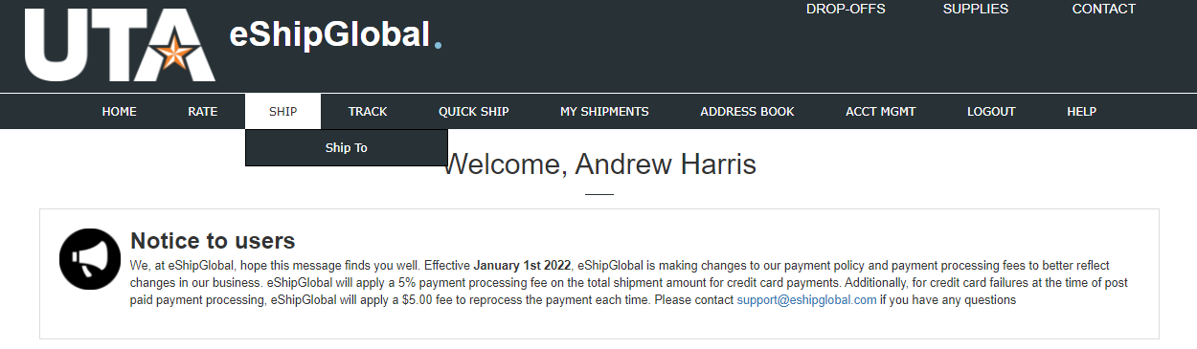
- Answer “yes” or “no” regarding the contents of your shipment. Answering “yes” will provide additional questions to determine if your shipment is Dangerous Goods/HAZMAT. Answering “no” will allow you to continue processing your shipment without Dangerous Goods/HAZMAT concerns. Select “International” for the shipment type.
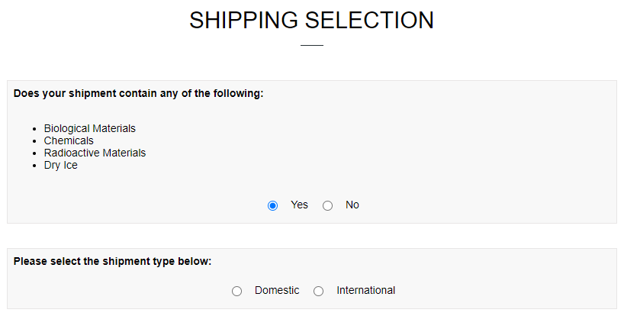

- If you selected “yes” you will see the following screen. If you selected “no”, go to next step. Once you have made your selection, eShipGlobal will continue to ask questions to determine your shipment’s Dangerous Goods/HAZMAT applicability. If determined that your shipment requires Dangerous Goods/HAZMAT certification/documentation, you will receive the notification below regarding “Training Verification” (2nd image). Continue to process your shipment and once completed, EH&S will review your shipment and provide the required certification/documentation and related instructions. If it is determined that your shipment does not require Dangerous Goods/HAZMAT certification, you will continue processing your shipment, and EH&S review and approval will not be required.
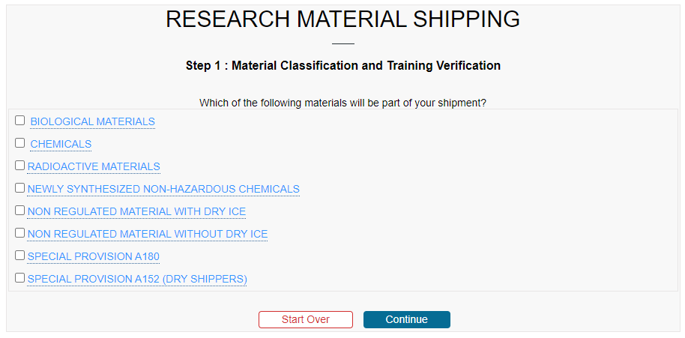

- Select the type(s) of item(s) you are sending. You can hover over each selection for the definitions provided by eShipGlobal. In this context, “technical data” (or “technology”) refers to information necessary for the development, production, use, operation, installation, maintenance, repair, overhaul, refurbishing, or modification of an item. This may be in any tangible or intangible form, such as written or oral communications, blueprints, drawings, photographs, plans, diagrams, models, formulae, tables, instructions, engineering designs and specifications, computer-aided design files, manuals, documentation, or electronic media.
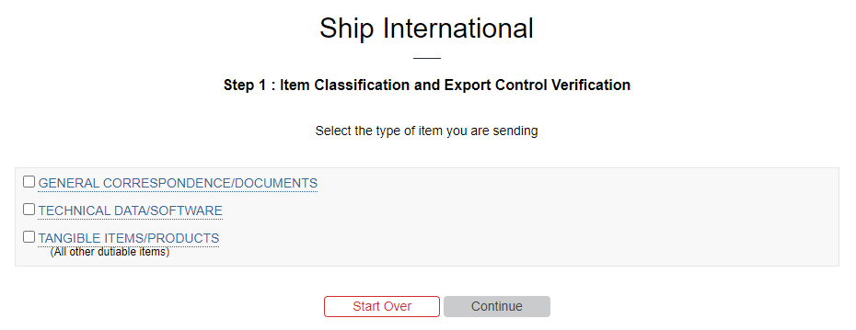
- You will then be directed to the next step based on your choice. You will see one of the 3 following options:
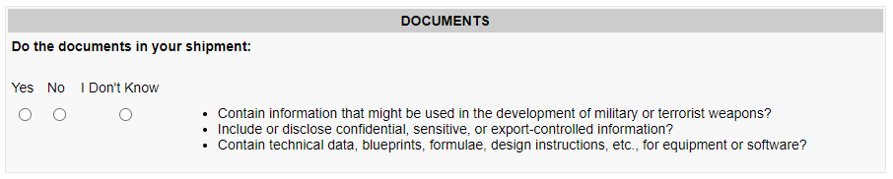
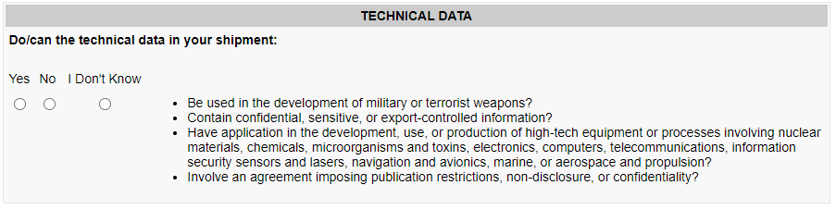
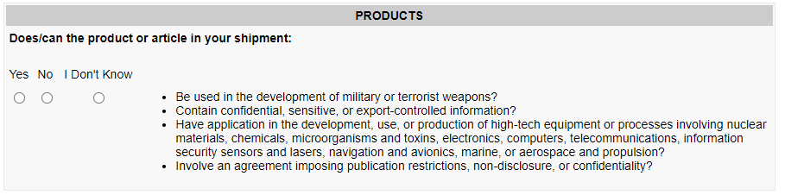

- Regardless of your choice, your next step will be to enter the required details related to the item you are shipping. You will either see a shortened version for document shipments, or a longer version for Technical Data or Tangible Item/Product shipments. Please see additional information below each image.
Shortened version for document shipments
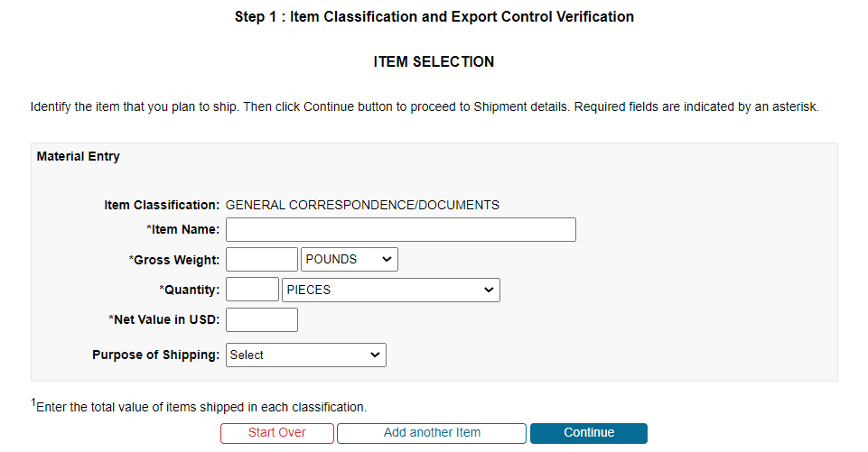
Item Name - please include a description of the type of documents you are shipping, for example “DS2019 documents.”
Net Value in USD - you must enter a value other than “0.” Entering a value of “1” is acceptable for document shipments having no commercial value. Typically, providing a commercial invoice for document shipments is not required and there are generally no import duties to consider at the foreign destination.
Purpose of Shipping - Select the option which best describes your shipment.

Longer version for Technical Data or Tangible Item/Product shipments
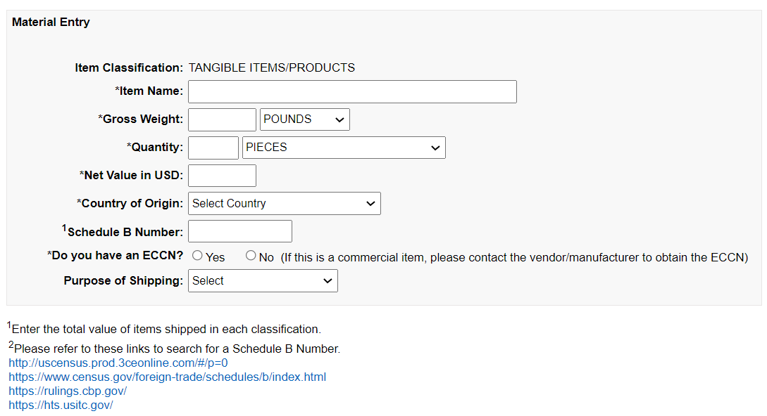
Item Name - provide a specific item description, rather than a general one. For example, “Copper Cysteamine nanoparticles sample, powder form” vs. “nanoparticles sample”. For items which are not being sold, and will not be sold in the foreign destination, it is recommended to add “-NOT FOR SALE” at the end of your specific description. So, the full description in this example would be “Copper Cysteamine nanoparticles sample, powder form-NOT FOR SALE.” This may help foreign customs to consider the shipment as non-dutiable/lower duty when there is an applicable exception allowable.
Quantity - this is meant to accurately represent the contents of your shipment. Choose a quantity, and quantity measurement/description which allows an accurate representation.
Net Value in USD - If the product were being sold as part of the international shipment transaction, this would be the sale price. Otherwise, the value should be the cost of procuring the goods, the cost to create the goods including labor costs, the estimated value if the goods were to be sold, or another accurate representation of value. In this case, it is NOT appropriate to enter a value of “1.”
Country of Origin - this should be the country where the item was manufactured, and/or became the final item/product that it is currently. This does not refer to the country where the shipment is originating.
Schedule B Number - this is the export classification(s) of the item(s) in your shipment. For shipments valued at $2,500.00 or less per Schedule B Number this information is not required to be entered to most destinations. It can be helpful to include this information if known, as it can help to ensure that the import process at the destination is completed accurately. Information on determining this classification can be found utilizing the following links:
- http://uscensus.prod.3ceonline.com/#/p=0
- https://www.census.gov/foreign-trade/schedules/b/index.html
- https://rulings.cbp.gov/
- https://hts.usitc.gov/
Do you have an ECCN? - If you have this information from the manufacturer or supplier, enter the ECCN. Please provide documentation of ECCN information to regulatoryservices@uta.edu to be reviewed in conjunction with your shipment. If you do not have this information, and are unable to obtain it from the manufacturer/supplier, enter “No.” You will then be prompted to complete additional fields (see image below). Regulatory Services will receive an automatic notification to review your ECCN designation prior to shipment approval.
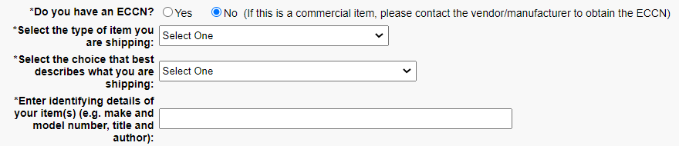
Purpose of Shipping - Select the option which best describes your shipment. If you are shipping material in support of a research project, it is recommended that “Other” is selected and “FOR RESEARCH PURPOSES ONLY” is entered into the additional field populated.
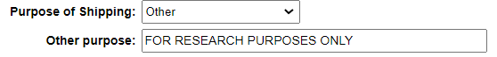
- Next you will be taken to the “Shipment Creation and Documentation” screen to enter recipient and customs information.
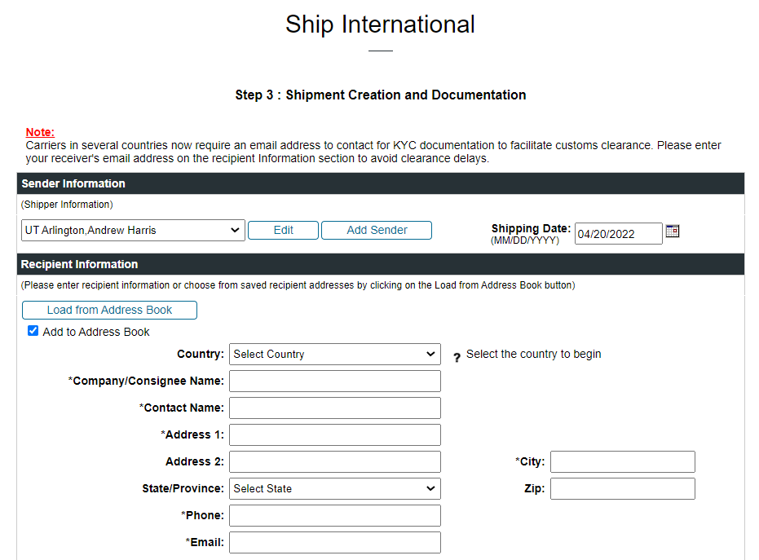
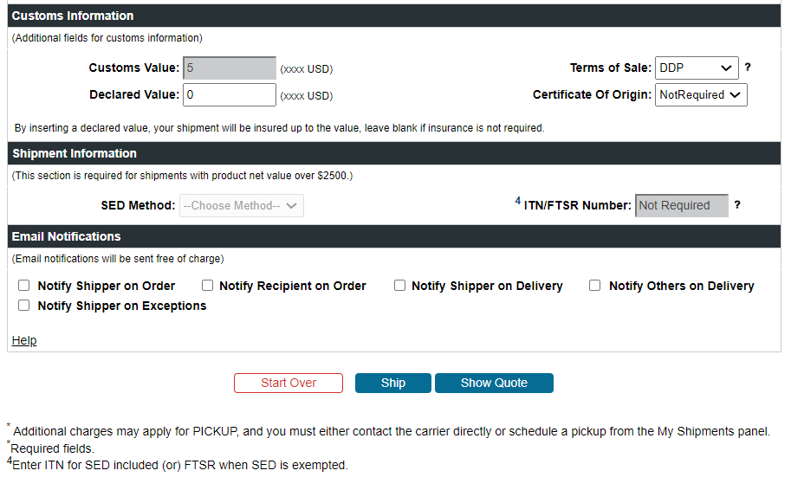

Customs Value - This is automatically populated from the information already entered.
Declared Value - By inserting a declared value, your shipment will be insured up to the value; leave blank if insurance is not necessary. For more information on declared value, visit the corresponding carrier website as follows:
UPS - https://www.ups.com/re/en/shipping/services/value-added/declared-value.page
FedEx - https://www.fedex.com/en-us/shipping/declared-value.html
DHL - https://mydhl.express.dhl/gd/en/shipment/shipment-protection-options.html
Terms of Sale - Given that most of UTA’s shipments are usually low value, “DDP” is usually the most effective choice. “Delivered Duty Paid” has the carrier pay the customs charges at the foreign destination on the shipper’s behalf. This usually helps to ensure that the package is cleared through customs and delivered quickly. The potential downside is that if the shipment is cleared incorrectly, it can be very difficult to correct that clearance and reduce the charges. This is one reason for clearly indicating the type of shipment utilizing the strategies described previously, such as adding “NOT FOR SALE” to the item description, selecting “Other” for “Purpose of Shipping” and adding “FOR RESEARCH PURPOSES ONLY.” These are just examples; be sure not to misrepresent any information and only use these designations if they truly fit for your shipment. Such descriptions may help to show customs the true nature of the shipment and utilize any duty/tax import exceptions that may be available.
If you have a high value shipment, it is recommended that you contact the planned recipient to discuss the best strategies/information to include in the shipment and/or commercial invoice so that customs duties exceptions (when available) will be utilized for clearance. In some destinations, such as EU countries, there is a 21% Value Added Tax (VAT) charge, plus the product tariff rate. This can result in a customs charge of 25-30% of the item’s value. A shipment valued at $2,000 could incur customs charges of $500 to $600 in this scenario which the shipper pays automatically under DDP terms. There may be no exception available.
Another option is to use Delivered Duty Unpaid (DDU) terms. In this case, the carrier will not pay the customs charges at the foreign destination on the shipper’s behalf. Instead, the recipient will be charged the import duties and taxes for the customs clearance to take place. The carrier should automatically contact the recipient, which should ensure a proper clearance takes place according to the importer’s instruction and any available exceptions to duties and taxes. It should be known that utilizing DDU terms could delay the delivery of the shipment as it will not deliver until the customs process is complete, and the recipient has paid the customs charges. If utilizing DDU terms it would be best to also change the “Bill Duties/Taxes To” selection to “Recipient” and list their account number.
Certificate of Origin - This is a document which is usually only required when a product is imported utilizing a free trade agreement between two countries. Leave selection as “Not Required.”
SED Method - If your shipment is valued at $2,500.00 or less (per Schedule B classification) and your product is ECCN EAR99, the selection should be left as “Not Required.” If your shipment does not fit these parameters, leave as “Not Required” and continue processing your shipment. The Office of Regulatory services will receive an automatic notification to review your shipment.
- Once all information is complete, select “Ship” at the bottom of the page (or first select “Quote” if you still need to compare rates and services, this requires leaving the service option unchosen). The following box will appear. Select “cancel” if you would like to review/edit your shipment. Select “ok” to proceed.
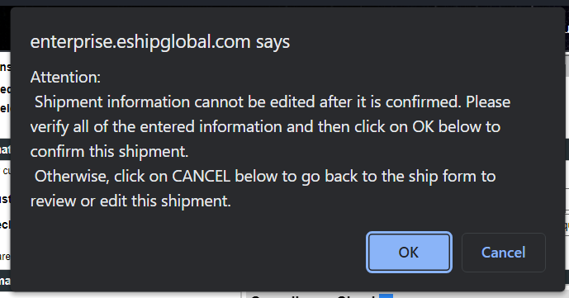
- eShipGlobal will review your shipment for export compliance concerns and the result will either be a green check meaning your shipment has been approved, or a red “x” meaning that your shipment requires review and approval from the Office of Regulatory Services.

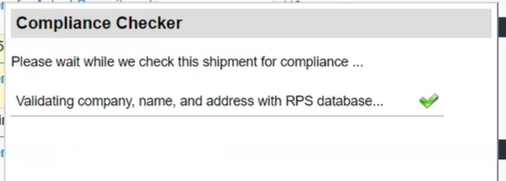

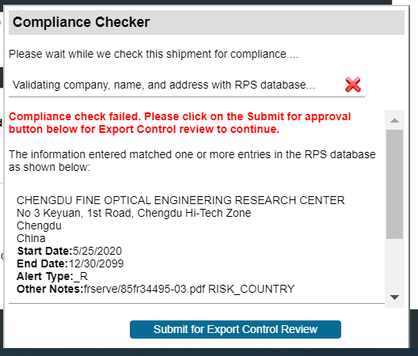

If approval is required, select “Submit for Export Control Review”. An automatic notification will be sent by eShipGlobal to regulatoryservices@uta.edu to review and approve the shipment. ORS will contact you by e-mail for more information if necessary. Once ORS approves your shipment you will receive an automated e-mail to finalize your shipment.

- Once approved, select “Complete Shipment”. If you were waiting for approval, you will need to log in to eShipGlobal and select your shipment to get to this step.
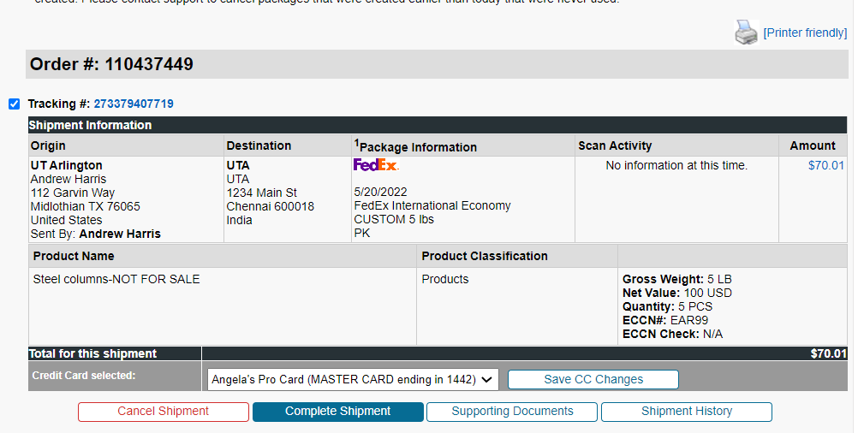

- Follow the instructions/review the information presented in the ”Compliance Checklist” prompt. Check the certification at the bottom and select to “continue” once you have verified this information.
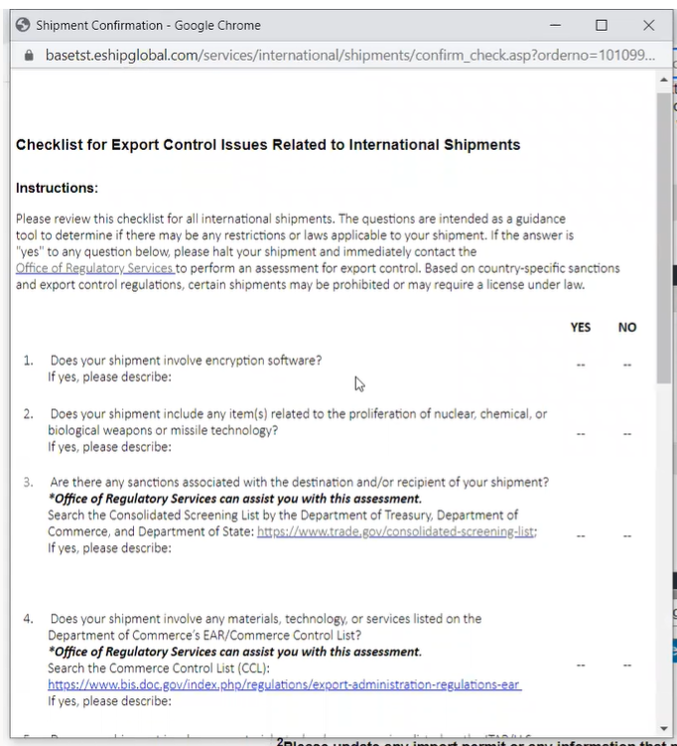
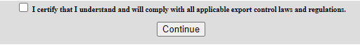

11) Print your shipping labels utilizing the “Print Airwaybill” button, apply them to your package. Print 3 copies of the commercial invoice utilizing the “Print Required Documents” button, sign each one, and include them in a pouch on the outside of your package. A commercial invoice is not normally required for shipments of documents. Drop your package off with the selected carrier.
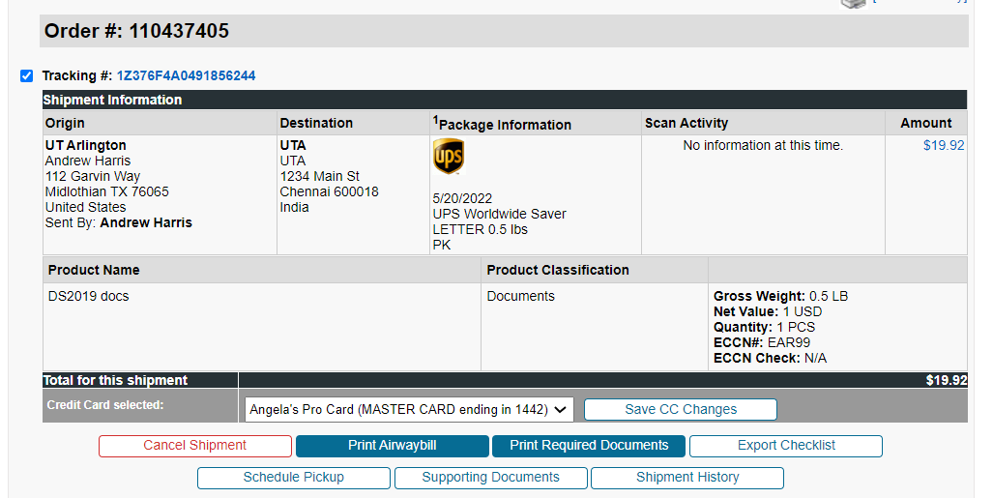
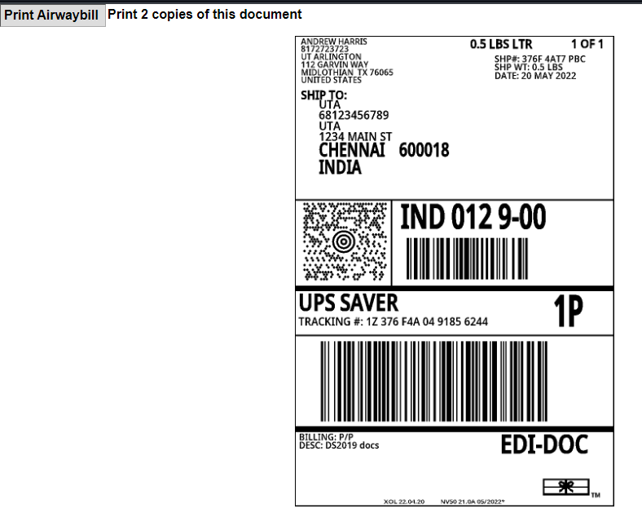
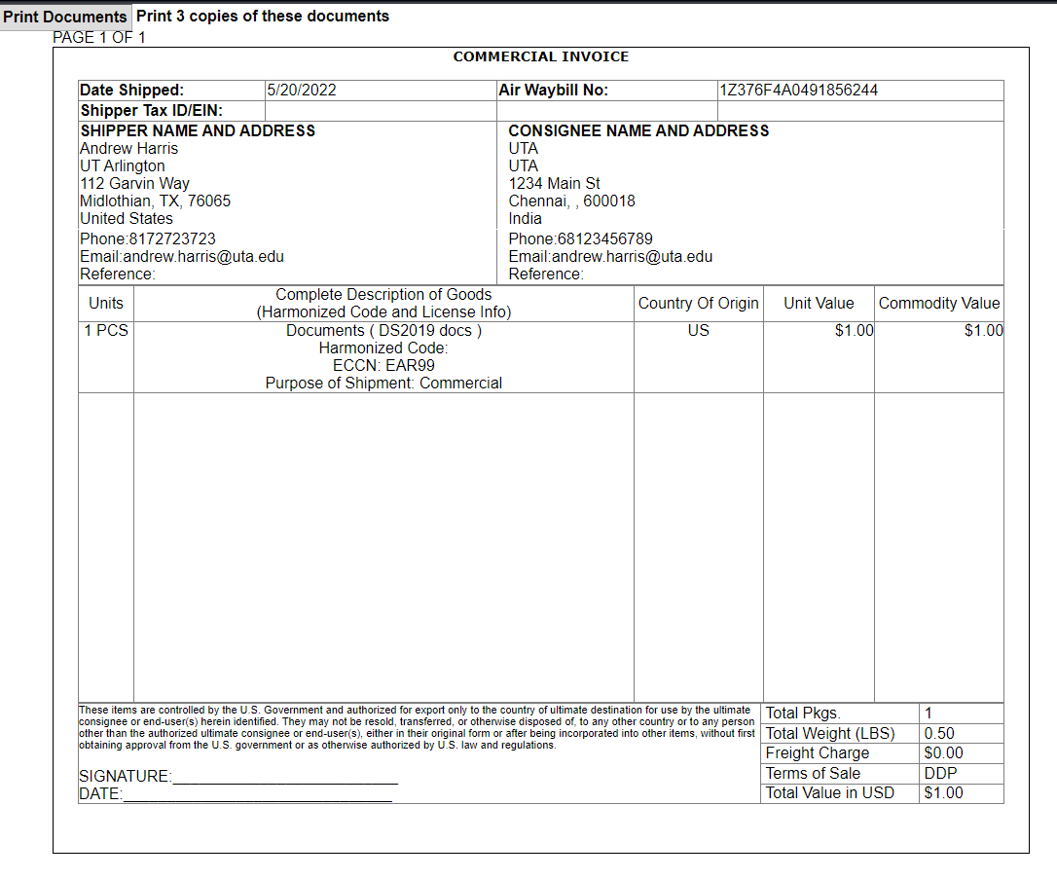
12) Keep all records to be retained related to your shipment for a minimum of 5 years. For additional specific requirements see comprehensive EAR and ITAR recordkeeping requirements as follows:
EAR - https://www.bis.doc.gov/index.php/documents/regulations-docs/429-part-762-recordkeeping/file
ITAR - https://www.ecfr.gov/current/title-22/chapter-I/subchapter-M/part-122/section-122.5

